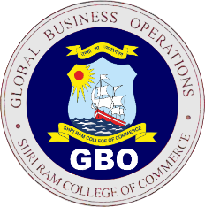
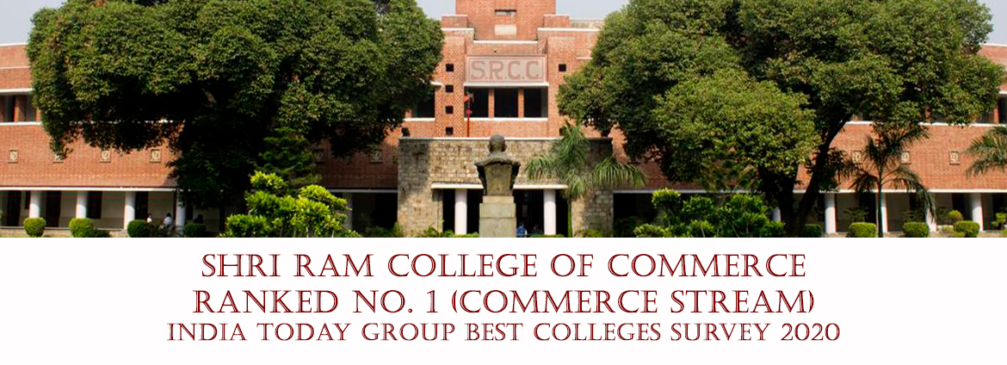

Industry Interaction Session Report
Event Details:
Event Name: Industry Interaction Session for GBO Batch 23-25’
Date of Event: 3rd February, 2024 (9:00 AM)
Guest Speaker Details:
Name of Speaker: Mr. Lakshya Gupta
Company: Gartner
Position in the company: Finance Research Specialist
Speaker LinkedIn: https://www.linkedin.com/in/lakshyagupta1
About Speaker:
- Mr. Lakshya excels in Business Intelligence, Marketing, and Development, leading teams in competitions and geographic expansion.
- Received "Best Intern of the Year" for surpassing sales targets and creating an effective sales funnel for a corporate client.
- He is skilled in SQL, Power BI, VBA, R, and Python, specializing in data and customer analytics.
Committee Tasks:
- Enabled student-alumni engagement through industry talks and simulated interviews, fostering connections.
- Improved SRCC Alumni database by verifying 200+ profiles for better networking with updated contact details.
Lecture Insights:
Mr. Gupta highlighted the following aspects in his session:
1. He emphasized the importance of tailored CVs and ensured compatibility with ATS.
2. Highlighted the benefits of tools like Resume Worded and navigating Naukri.com for enhanced CVs.
3. Stressed on the impact of portfolios and the significance of volunteering experiences.
4. Introduced us with resources like AnalyticsLab.co.in and provided insights into relevant certifications.
Social Media Link:
Instagram- https://www.instagram.com/p/C29skh_vsGV/?igsh=aGUzNW4zNGY0OHhp
Linkedin- https://www.linkedin.com/posts/alumnati-the-alumni-society-of-srcc-gbo_srcc-alumni-alumnitalk-activity-7160238047459004416-qwiH?utm_source=share&utm_medium=member_android
Hosted By:
ALUMNATI, the Alumni Relations Society- SRCC GBO

